The Peer-Led Team Learning International Society
Proceedings of the Inaugural Conference
May 17-19, 2012
New York City College of Technology of
the City University of New York
Brooklyn, NY 11201-2983

The PLTL Leader Boost
Jose Luis Alberte, Alberto Cruz, Nataly Rodriguez, Thomas Pitzer

Abstract
Qualitative data has demonstrated the impact of PLTL on a Peer Leader’s academic performance. In this paper we quantitatively show the presence of the Peer Leader boost at Florida International University. Just as in any apprenticeship role, Peer Leaders undergo an extensive training program and it is this experience which provides an advantage. Training includes pedagogy, classroom dynamics, science concepts, and critical thinking skills equipping Peer Leaders with the necessary skills to manage a productive active learning environment. Initial observations and feedback indicate that participation as a Peer Leader adds value such as enculturation in the discipline, increased performance in traditionally assessed learning outcomes, and increased retention within the discipline. Preliminary data demonstrates a significant difference in the academic success of Peer Leaders in their own course work. This analysis was performed on large enrollment upper-level courses which indicated up to a letter grade difference between Peer Leaders and non-Peer Leaders.

Introduction
Peer-Led Team Learning (PLTL) recruits motivated Science, Technology, Engineering, and Mathematics (STEM) students to act as group mentors. The group mentors are trained in pedagogical techniques, group dynamics, and scientific concepts. PLTL was originally a project implemented in response to the widespread concern about the quality of first year STEM education, poor test taking performance in science courses, and perceived inability to think critically in scientific scenarios at Florida International University (FIU).
This student-centered learning paradigm is firmly rooted in active learning pedagogies ,which provides students with the opportunity to build stronger foundations, focus on information retention, and make connections across concepts and disciplines. These tools equip students and prepare them for the learning they face throughout their collegiate careers and beyond. FIU’s PLTL centralized tiered-team group learning model is now well established and entrenched within the college incorporating over a dozen courses in the Biology Department (majors and non-majors, lower and upper-level courses).

Learning about Learning
One of the best ways to learn how to study is to learn about foundational elements of education. STEM undergraduate students have no pedagogy course requirement. Peer Leaders (PLs) during their apprenticeship learn the fundamentals of education. This gives these students an opportunity to acquire true understanding of a students’ learning process. Therefore, by learning about learning this helps them understand how they, in turn, learn. This advantage allows PLs to be more metacognitive about their own learning in their STEM courses, which should result in higher performance and retention. Students retain information for the long term more effectively when they engage in an activity where they actively say and do something. One of the best ways to learn is to teach or facilitate that content to others. PLs should perform better because they run discussions with their peers about subjects related to their undergraduate degree and are trained to do so properly.
PLs are required to attend a pre-semester orientation regardless of whether they are a first time PL or a PL returning for their 10th semester. Tailoring orientation to the experience of PLs ensures participants gain valuable knowledge regardless of their prior participation. Separate workshops are designed to enhance the PL’s pedagogical foundations. New PLs attend an entry-level session called the “Foundations of Pedagogy” workshop. Second semester PLs attend an “Intermediate Pedagogy” workshop. PLs serving three or more semesters attend an “Advanced Pedagogy” workshop. New and experienced PLs attend the “Protocol and Administration” workshop, where the PLs are trained in their administrative duties. They also participate in “Mock Sessions” guided by experienced PLs.
All PL training is run using active learning techniques. PL trainees are modeled through experiences similar to situations they will encounter during their sessions. Experienced PLs are present to serve as mentors to the novice PLs. In doing so, they are able to fine tune their own skills. FIU PLs are required to attend orientation every semester to reinforce the retention of the major features of the PLTL model.
Scaffolding is used throughout orientation to help the trainees gradually learn their role as a facilitator. Effective instructional scaffolding helps the student construct new knowledge by structuring the learning process for the student without telling the student exactly how to accomplish the task at hand. In addition to scaffolding, a trainees’ learning process is kept active throughout orientation. By keeping the learning process active during training it helps the trainees retain the learning goals of the session long term. Although direct instruction may seem momentarily more palatable, it can ultimately hinder the learning process and retention of the important information.
The Foundations of Pedagogy workshop is designed to introduce new PLs to the basic principles of teaching and learning. It is run as an active exploratory guide by expert PLs and program administrators. The majority of recruits have experienced PLTL as students, but are less aware of the role the PL should play in the workshop. PLs are presented with the reasoning for the workshop model. Trainees are split into small groups with at least one experienced PL who acts as the discussion facilitator during the workshop. It is important to note that each task must be discussed as a large group to consolidate ideas and supplant misconceptions. To address a variety of learning styles, it is imperative to have each small group write down the ideas discussed while they are working together. This facilitates the large group discussion. The use of large (20” x 23”) self-adhesive note pads or small white boards per group is recommended.
Trainees are first directed to define the terms Peer, Leader, Team, and Learning in small groups. Defining these terms helps trainees realize their foundational goals as PLs. The activity reveals the pedagogical foundation of the workshop model. Trainees discuss memorable learning experiences. Those experiences are then discussed and relevant learning points are addressed. In small groups, trainees are instructed to list examples of good and bad learning experiences. Trainees elaborate on the characteristics which make good and bad learning experiences. This exercise allows the trainees to make connections between their own experiences and the new pedagogy.
To be effective, PLs need to understand and be able to apply basic pedagogy in the classroom. They are expected to make a connection between their own experiences as students and good active learning practices. To accomplish this objective, trainees compare and contrast active and passive learning activities, identifying examples of each. Trainees use this knowledge to make the connection to the Cone of Learning and effective pedagogical practices (Dale, 1969).
PLs facilitate workshop progress through the use of questions. Initially, this is difficult for students not used to the Socratic Method. PLs are carefully scaffolded and modeled in the construction and use different types of questions. PLs learn to differentiate between open and closed questions. The importance of using open-ended questions serves to facilitate peer-to-peer conversation and to accomplish student learning objectives. PLs need to vary their level of questioning, based on Bloom’s Taxonomy, to ensure basic critical thinking skills. Trainees practice the difference between knowledge, comprehension and critical thinking based questioning, which assists PLs to achieve these goals(Bloom, 1956).
The Intermediate Pedagogy workshop addresses specific pedagogical strategies that can be implemented in any classroom setting. A practical approach is taken for this workshop, where the trainees learn about the learning strategy by actually practicing the technique as it is learned.
As part of training, we emulate the same active learning techniques used in workshop sessions. We use the Jigsaw Method, a collaborative learning strategy involving small groups, where information is put together, piece by piece, like a jigsaw puzzle, to understand a big picture concept. There are several other practical exercises performed during this training session which include creating one-sentence summaries, differentiating between brainstorming, flow charts, concept mapping, and Think-Pair-Share techniques.
In addition to the practical component of this workshop, PLs are guided to make connections to major pedagogical theories essential to STEM education and PLTL. Vygotsky’s Zone of Proximal Development (ZPD) is at the pedagogical foundation of the workshop model. ZPD can be defined as the difference between a person’s developmental level or ability to independently problem solve and a person’s potential to solve a problem with the guidance from an expert or a capable peer (in other words, a more knowledgeable other). PLs learn how to properly restructure typical classroom time and curriculum to reflect constructivist learning theory. The objective of this part of the training session is to have PLs acquire basic knowledge of the ZPD and be able to apply it during their workshops. This would involve an understanding of the importance of facilitating the evolution of a novice's thought process into an expert's academic mindset. The role of the PL as a more capable peer, or more knowledgeable other, is to guide PLTL students through their own learning process and better equip students, helping them understand how to navigate themselves through future learning experiences (Vygotsky, 1978).
In the Advanced Pedagogy workshop, the topic changes with each orientation. Changing the topics discussed in the workshop maintains an effective and fulfilling learning experience for PLs who remain with the program for multiple semesters. This workshop addresses current issues or hot topics, although many pedagogical topics qualify for discussion. Addressing modern issues in STEM education is a good place to start determining how PLTL improves academic success. Topics include: defining and applying critical thinking as a vital part of PLTL, making the connection between learning and memory, and designing better question stems.
To be a supervisor, volunteers must have experience as a PL for that curriculum. They must also show exceptional attributes related to their duties as a PL. Each supervisor completes an evaluation survey during each supervising session detailing all of the necessary features of a successful PLTL workshop. After each monitored workshop, the supervising PL provides constructive feedback on how to improve a PL’s workshop. Supervisors follow their evaluation with post-workshop meetings to discuss their observations and how the PL can maximize strengths and identify potential areas for growth. It gives the PLs an additional opportunity to improve their own skills through the guidance of a more knowledgeable other. This feedback system also allows the supervisors to have an additional mentorship and leadership role.
PLs attend a discussion group as part of the PL’s weekly training regimen, where both content and pedagogy are discussed. This forces the PLs to revisit concepts previously learned during their undergraduate career. The nature of this discussion allows PLs to clear up their own misconceptions and make connections that they were not able to the first time around. There are several anecdotes indicating that PLs learn more content knowledge and acquire a better understanding of the material as a result of being a PL.

Results

Semester | Course | Leader Status | Avg Grade | SD | T-Test Value
Fall 2011 | Genetics | Non-Leader | 2.42 | 1.256 | 0.0000068*
 |  | Leader | 3.44 | 0.629
 | Ecology | Non-Leader | 2.84 | 1.051 | 0.0499*
 |  | Leader | 3.25 | 0.897
 | Evolution | Non-Leader | 3.06 | 0.793 | 0.00000000055*
 |  | Leader | 3.86 | 0.359
Spring 2012 | Genetics Sec. 1 | Non-Leader | 2.80 | 0.976 | 0.000000045*
 |  | Leader | 3.61 | 0.499
 | Genetics Sec.2 | Non-Leader | 3.09 | 0.805 | 0.00098*
 |  | Leader | 3.55 | 0.510
 | Ecology | Non-Leader | 3.23 | 0.816 | 0.4753
 |  | Leader | 3.00 | 0.943
 | General Microbiology | Non-Leader | 2.15 | 0.985 | 0.041*
 |  | Leader | 2.55 | 0.995

Figure 1. Fall 2011 and Spring 2012 Peer Leader vs Non-Peer Leader Course Grades

During the Fall 2011 semester, the upper-level Genetics, Ecology, and Evolution courses were assessed based on PL performance. The students in the courses were split into two categories: PLs (previous or current) and non-PLs. Their course grades were averaged, and the standard deviation and two-tailed t-tests (p< 0.05) were performed to show statistical significance. These finding are shown in Figure 1. All three of the courses showed a higher statistically significant average course grade for PLs. Each of these courses is required for the completion of a B.S. degree in Biology at FIU.
During the Spring 2012 semester, the upper-level Ecology, General Microbiology, and both sections of Genetics were assessed based on PL performance, similarly to the Fall 2011 semester. The students in these courses were also split into two categories: PLs (previous and current) and non-PLs. Their course grades were also averaged, and the standard deviation and two-tailed t-tests (p< 0.05) were also performed. These finding are also reported in Figure 1. Three out of the four courses demonstrated a higher statistically significant average course grade for PLs. These three courses included General Microbiology and both sections of Genetics. The Ecology course did not demonstrate higher average course grades for PLs. This assessment of student grades in this course, were not statistically significant. General Microbiology is a large-enrollment, elective course for the B.S. degree in Biology at FIU. However, many of the undergraduate biology students at FIU, are on a pre-health track, which requires this course.

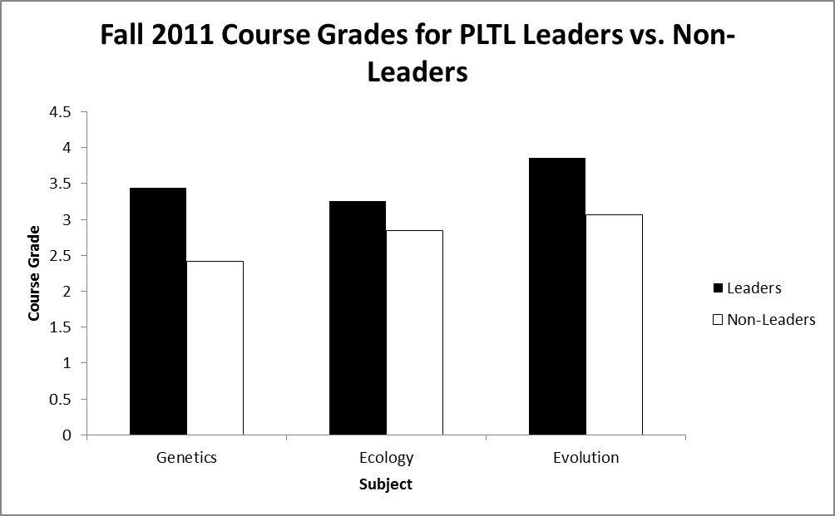

Figure 2.Graph comparing student average course grades for Genetics, Ecology, and Evolution during the Fall 2011 semester, for PLs (Leaders) and non-PLs (non-leaders).

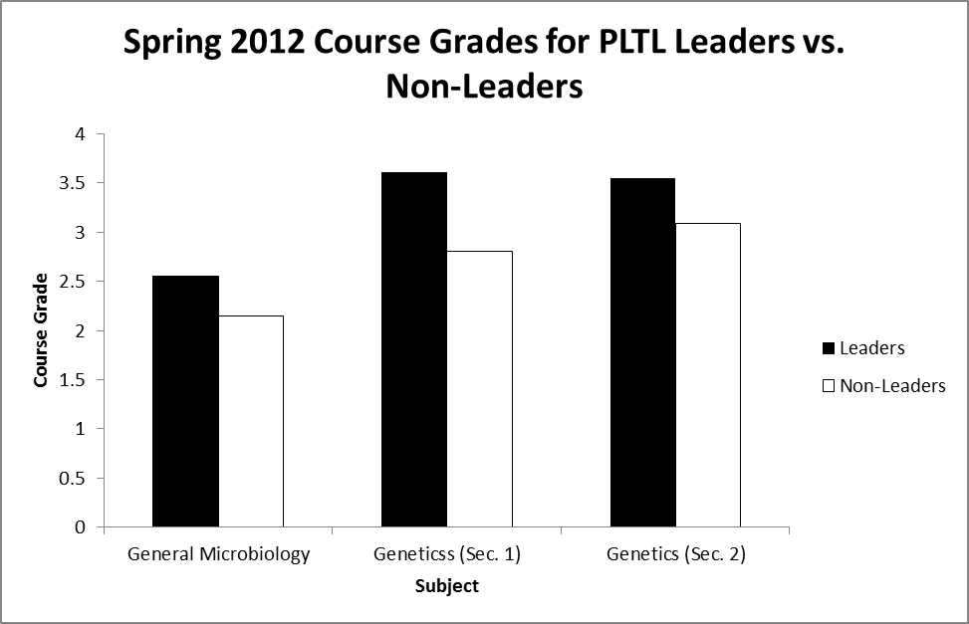

Figure 3: Graph comparing student average course grades for Genetics (sections 1 and 2), and General Microbiology during the Spring 2012 semester, for PLs (Leaders) and non-PLs (non-leaders).

Discussion
These preliminary analyses demonstrate that PLs who were currently leading a workshop, or previously led a workshop, outperformed their peers, taking the same course, who were not PLs. This was shown across two semesters, in required majors courses (Genetics, Ecology, and Evolution), and in an elective majors course (General Microbiology). The most notable difference between PLs and non-PLs was shown in the Genetics course in Fall 2011. Here, PLs performed, on average, 1 grade point higher than those who were not PLs (Figure 1). The courses in this preliminary analysis were taught by different instructors, except for the Fall 2011 Genetics course and Genetics (section 1) course in Spring 2012. However, regardless of the instructor a similar effect on a PL’s academic success was observed across the courses. Higher performances in courses, could lead to higher retention within the major, and higher graduation rates. Analyses to demonstrate these correlations, will be performed in the future.
This improvement in academic success by PLs is complimentary to anecdotes and qualitative data collected by various institutions on the PL experience (Gafney and Varma-Nelson, 2008).There is a positive correlation between academic success and a student’s apprenticeship time in PLTL. These results highlight the body of evidence that the quality of time on task is highly influential in academic success. Additionally, these results suggest that the PL experience may strongly influence student retention, especially among underrepresented minority groups in STEM disciplines.
Great focus has been placed on analyzing and understanding the boost that undergraduate students acquire when actively participating in PLTL, but it is suspected that the PLs gain the most out of the PLTL experience. Short-term research goals are focused on analyzing and understanding the extent in which PLs develop academic, interpersonal, social, and leadership skills. In time, there are hopes to collaborate with PLTL practitioners to create a network of educational researchers aimed at solving PLTL-related inquiries.

References
Bloom, B. (1959).Taxonomy of Educational Objectives, Handbook I: The Cognitive Domain. New York, NY: David McKay.
Dale, E. (1969). Audio-visual methods in teaching. New York, NY: Dryden Press.
Gafney, L., and Varma-Nelson, P. (2008). Peer-Led Team Learning: Evaluation, Dissemination, and Institutionalization of a College Level Initiative. In: Innovations in Science Education and Technology Vol 16. New York, NY: Springer.
Vygotsky, L. S. (1978). Mind in Society: The Development of Higher Psychological Processes. Cambrige, MA: Harvard University Press.

Cite this paper as: Alberte, J.L., Cruz, A., Rodriguez, N., Pitzer, T. (2013). The PLTL leader boost. Conference Proceedings of the Peer-Led Team Learning International Society, May 17-19, 2012, New York City College of Technology of the City University of New York, www.pltlis.org; ISSN 2329-2113.

