Pratibha Varma-Nelson is the winner of the 2018 George C. Pimentel Award in Chemical Education. This award, sponsored by Cengage Learning and the ACS Division of Chemical Education, recognizes outstanding contributions to chemical education.

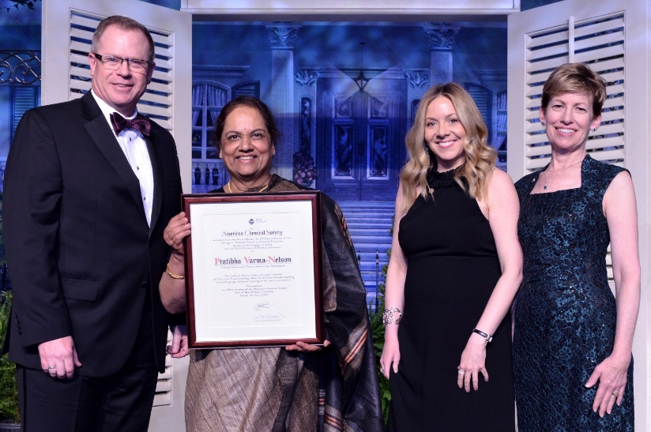

Left to right:  Peter Dorhout, ACS president 2018; Pratibha Varma-Nelson; Maureen McLaughlin, representative from Cengage, sponsor of the award; and Cheryl Frech, Chair of DivCHED (Division of Chemical education at the ACS).

Pratibha Varma-Nelson, professor of chemistry, and founding Executive Director of STEM Education Innovation and Research Institute at IUPUI in Indianapolis, Indiana, is one of the original practitioners of Peer-Led Team Learning.

In recognition of the George C. Pimentel award, a symposium [LINK TO PIMENTEL AWARD SCHEDULE AND ABSTRACTS] was held on Tuesday, March 20th, 2018 in New Orleans, Louisiana and featured speakers who have intersected with Pratibha’s efforts in promoting Peer-Led Team Learning and chemical education over the past twenty years. Speakers and their topics are listed below. The abstracts of the talks are available [LINK TO PIMENTEL AWARD SCHEDULE AND ABSTRACTS].

Susan Hixson, *Support by the National Science Foundation for the development of peer-led team learning*

Anthony Chase, *Transferrable skills gained from experience as a peer-leader in a PLTL program: Reflections, applications, and long-term impacts on professional lives*

Brian Coppola, *Attending to the subject*

Mark Cracolice, *Theoretical cognitive foundations for peer-led team learning*

Joseph Dinnocenzo, *Peer-led team learning applied to laboratory instruction*

Ingrid Druwe, *Oh, the places you’ll go: The dissemination and implementation of the peer led team learning project, a unique student-faculty partnership*

Joseph Kinsella, PLTL: *Experience from both sides of the desk*

Jennifer Lewis, *Peer-led team learning and Pratibha Varma-Nelson - irrepressible*

*and resilient*

Kevin Mauser and John Sours, *From face-to-face to online: Collaboration in design and*

*implementation of cPLTL*

Richard Moog, *Three Big P’s: POGIL, PLTL, and Pratibha*

Simon Rhodes, *Peer-led team learning in science and engineering at IUPUI*

Susan Rodger, *Implementation and evolution of PLTL in introductory computer science courses*

Gabriela Weaver, *Course-based undergraduate research via the CASPiE Project: From idea inception to cross-institutional networks*

Sarah Wilson, *Assessing the development of curved-arrow formalism mastery among first-semester organic chemistry PLTL and cPLTL students*

Donald Wink, *Bringing peer learning into the laboratory and research setting*

Lance Shipman Young, *A multidisciplinary intervention to ensure success in STEM gatekeeper courses at Morehouse College*

Pratibha Varma-Nelson, *Award Address. Reflections on a non-traditional academic career: Lessons for the future*

For more information on the STEM Education Innovation & Research Institute, visit <https://seiri.iupui.edu/>

For more information on the George C. Pimentel Award in Chemical Education, visit <https://www.acs.org/content/acs/en/funding-and-awards/awards/national/bytopic/george-c-pimentel-award-in-chemical-education.html>

For IUPUI’s release, visit <https://www.eurekalert.org/pub_releases/2018-03/iuui-iso031918.php>